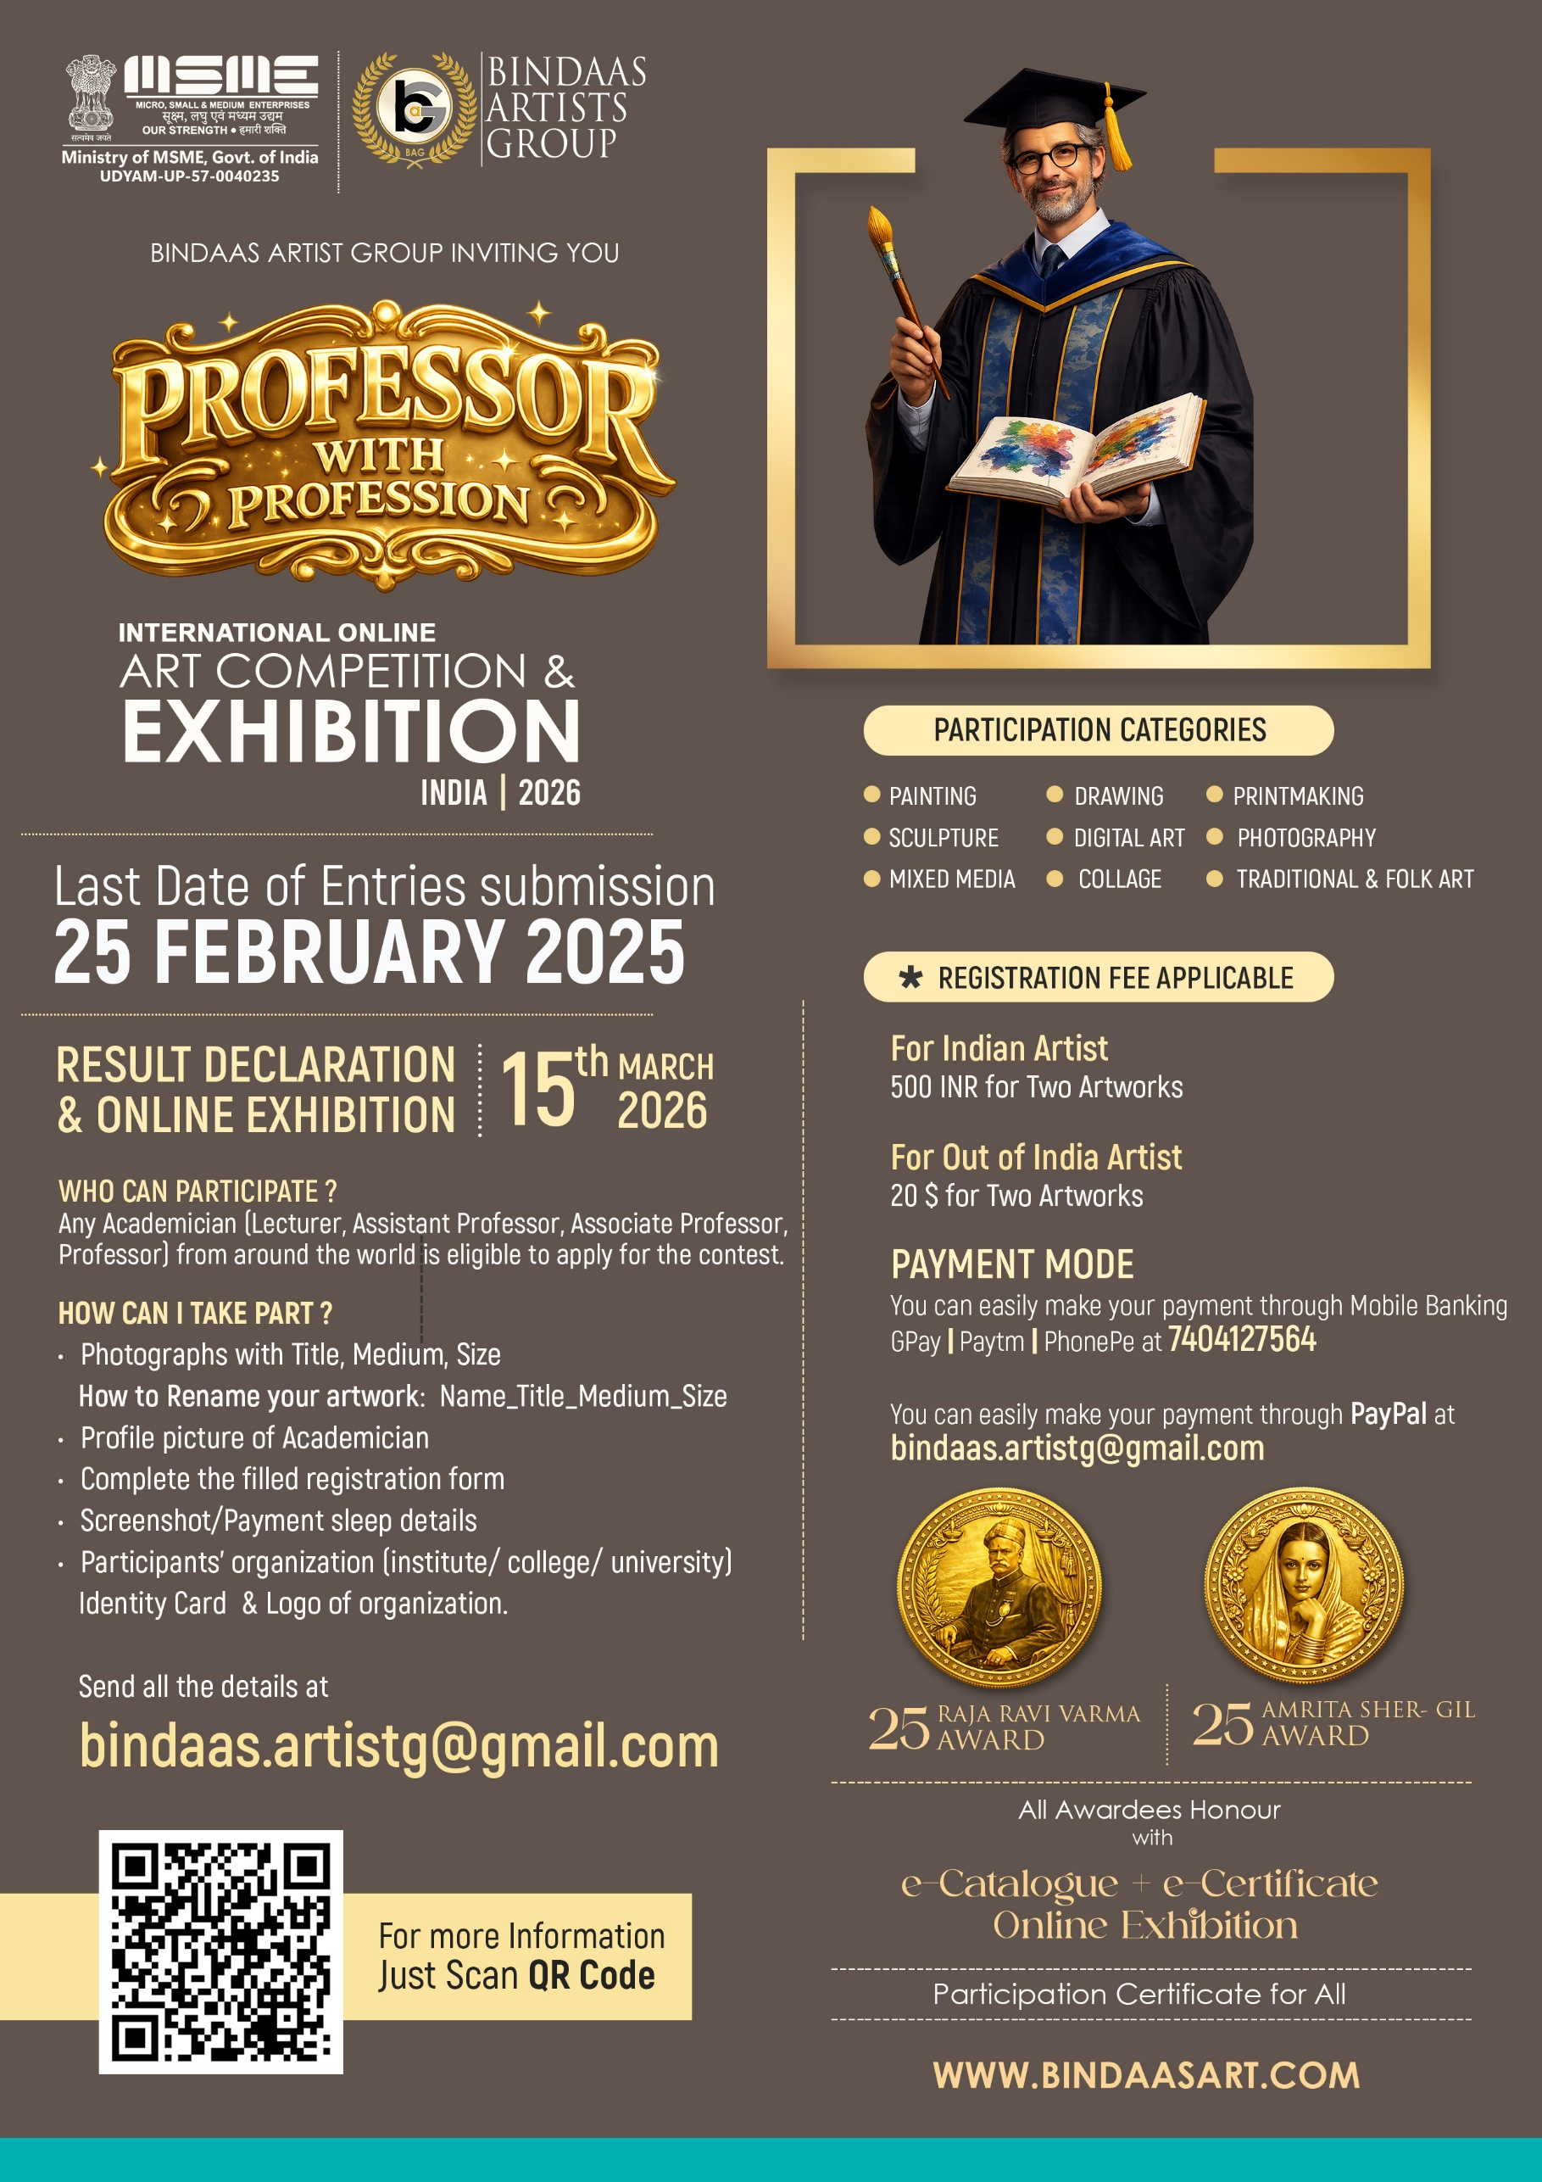
Registration Form
Name |  | Place
Email |  | Contact
Designation |  | Organization
Participating Category Artwork: (Like- Painting/Sculpture, Etc.)

Details Of Artwork First
Title |  | Medium
Size |  | Year
Details Of Artwork Second
Title |  | Medium
Size |  | Year
Registration Fee Details
Amount Pay |  | Mode Of Payment
Date |  | Bank/UPI Name
Transection Id

Declaration by the creator
I hereby declare that the artwork/work submitted by me is entirely original and created by me without any unauthorized copying, reproduction, plagiarism, or infringement of any existing artwork, image, text, or intellectual property. I confirm that I am the sole creator and lawful copyright holder of the submitted work.
I fully understand and agree that the organizing body has the absolute right to verify the originality of the submitted work at any stage of the event, competition, exhibition, or thereafter. If the artwork is found to be plagiarized, copied, misrepresented, or in violation of copyright or ethical standards, I grant full permission to the organization to:
- Refuse or cancel my entry
- Disqualify my submission without refund
- Remove my artwork from the event/exhibition
- Revoke certificates, awards, recognitions, or publications

Signature:
Name:
Place:
Date:



