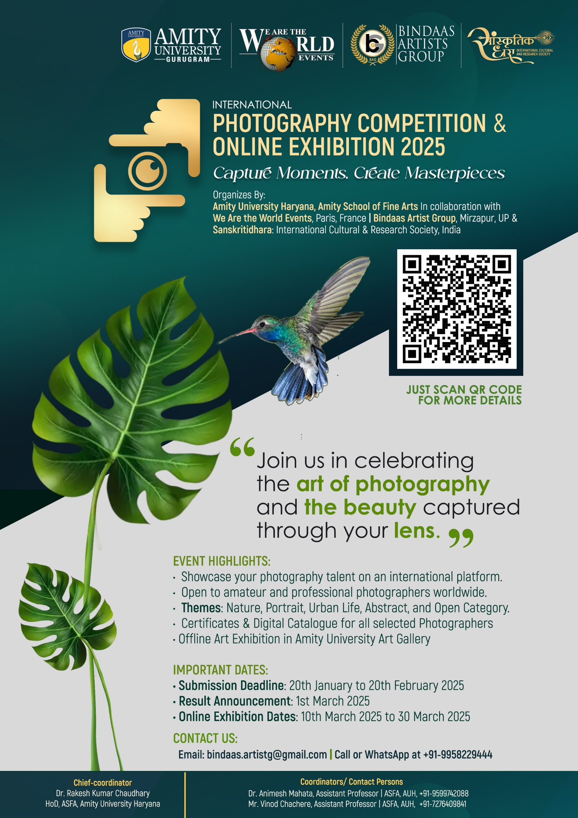

**International Photography Competition 2025**

**Registration Form**

Competition Theme: Open  
Submission Deadline: 20th February 2025

**Section 1: Personal Details**

1. Full Name: ___________________________Date of Birth___________________________
2. Gender: ☐ Male ☐ Female ☐ Other
3. Country: _____________________Address: ________________________________________
4. Phone Number: ___________________Email Address: ______________________________
5. Social Media Handles (Optional):
   * Instagram: ___________________________
   * Facebook: ___________________________
   * Website/Portfolio: _____________________

**Section 2: Submission Details**

1. Photo Title(s):
   * Title 1: ______________________________
   * Title 2: ______________________________
2. Category (if applicable):
   * ☐ Landscape
   * ☐ Portrait
   * ☐ Wildlife
   * ☐ Abstract
   * ☐ Other: _____________________________
3. Description of Submission(s):
   * Title 1: ______________________________
   * Title 2: ______________________________

**Section 3: Technical Details (Optional)**

1. Camera Used: _______________________
2. Lens: ______________________________
3. Settings (ISO, Aperture, Shutter Speed):
   * Title 1: ______________________________
   * Title 2: ______________________________
4. Editing Software Used (if any): _______________

**Section 4: Payment Details**

* Entry Fee Amount: ____________________________________________________________
* Payment Method: ☐ Bank Transfer ☐ Credit Card ☐ PayPal ☐ Other
* Transaction ID/Reference: ______________________________________________________
* I confirm that all submitted photographs are my original work and do not infringe on the rights of others.
* I have read and agree to abide by the rules, terms, and conditions of the competition.

**Signature: ___________________________  
Date: ______________________________**

**Amity University Haryana, Amity School of Fine Arts**

In collaboration with

**We Are the World Events, Paris, France | Bindaas Artist Group, Mirzapur, UP** &

**SANSKRITIDHARA: International Cultural & Research Society, India***Presents*

**International Photography Competition & Online Exhibition 2025**

*Capture Moments, Create Masterpieces*

*India, I am thrilled to extend a cordial invitation to you to participate in our highly anticipated International Photography Competition & Online Exhibition 2025. We believe that your artistic vision and creativity align perfectly with the ethos of our exhibition.*

​​**Objective:**  
The primary goal of this exhibition is to foster global artistic collaboration, provide exposure to eminent artists, and create a space for cultural exchange. It will also serve as an inspiration for emerging artists and art enthusiasts worldwide by showcasing works from distinguished creators across various genres and mediums.

​

**Event Format:**

This will be a fully virtual exhibition, allowing for widespread participation without geographical limitations. The exhibition will be hosted on a dedicated online platform, making it accessible to a global audience.​

​

**Event Highlights:**

• Showcase your photography talent on an international platform.

• Open to amateur and professional photographers worldwide.

• Themes: Nature, Portrait, Urban Life, Abstract, and Open Category.

• Certificates & Digital Catalogue for all selected Photographers

**Important Dates:**

• Submission Deadline: 20th January to 20th February 2025

• Result Announcement: 1st March 2025

• Online Exhibition Dates: 10th March 2025 to 30 March 2025

• Offline Art Exhibition in Amity University Art Gallery

**Registration Fee:**

**For Indians**: 100 Rupees for one photograph | 150 Rupees for two Photographs | **GPay | Phonepe | Paytm at 7404127564**

**For out of India**: 10$ For one photograph | 15$ For one photograph | **Paypal at bindaas.artistg@gmail.com**

(No registration fee for invited photographers)

**Guideline:**

* **File Format**: JPEG (as specified by the competition).
* **Resolution**: Ensure a high-resolution image (usually 300 dpi).
* **File Size**: Follow size limits (e.g., 5 MB to 10 MB).

​

**How to participate:**

**Enclosure for Email:**

* Photographs with Title, Size
* Profile picture of Photographer
* Complete filled registration form
* Screenshot/Payment sleep details

All the above enclosure shares at

**bindaas.artistg@gmail.com**

​Email bindaas.artistg@gmail.com or WhatsApp at +91-9958229444 with additional questions, comments, and inquiries about the Competition.

​